# Mental Health in Tech

Andrea Fox

Summer 2021

<https://github.com/anfox86/Mental-Health-in-Tech>

**Introduction**

For this project I found a dataset that I thought would be interested in which consisted of survey answers from 2014 regarding mental health in the tech industry. It feels like lately the tech industry has really focused on employee mental health and have been more understanding with leave, treatment, and sharing to other coworkers or supervisors about a mental health condition. However, this survey was completed in 2014 when mental health was not widely talked about.

I wanted to come at this project with the mind of a potential client. I am acting as a consultant for another tech company interested in investing in employee mental health but wanted to see how the rest of the industry approached the topic. By doing this it allowed my mindset to focused on how do I help my client instead of simply looking for random questions? This is typically how I work daily anyways, so it has made this project flow better for me than the first project I worked on.

**Business Problem/Hypothesis**

My dataset came from Kaggle and contains 27 different variables which can be found in table 1 in the Appendix. Since I am coming at this project as a consultant the biggest question I am trying to answer is does the tech industry take mental health conditions seriously? Do they provide their employees with the resources they need to stay mentally healthy? By looking at the existing resources and standards, I can help my client make a more informed decision on whether they are on par with the rest of the industry or if they need to make some improvements to provide a better mental health environment for their employees. So why is this important to my client? “Experts suggest that stress and anxiety in particular cost companies $30 billion in lost workdays each year.” (Davis, 2018) My client does not want to lose money especially at the amounts that are quoted in this article, but that is not the only reason to invest in employee mental health. There have been studies that “1 in 4 have mental health problems,” but really everyone has mental health just like they have physical health, and both need to be prioritized. (Lopukhina, 2020) It has finally become “ok” to talk about mental health and as well as seek treatment for a mental health condition, which is what my client wants to focus on.

**Clean-up**

After downloading the dataset from Kaggle, I then uploaded a copy into my Jupyter notebook so I could start my cleaning. One thing I did differently here is I made a list of things I knew needed to be fixed up before I could do a visual and technical analysis. This helped keep me on track and made the process faster and smoother than my previous projects. After I read in the data, I then printed a list of columns so I could see if there were any that needed to be removed. I ended up removing timestamp and comments. Timestamp was not useful to me since all the responses were from 2014, and if I wanted to look at timestamp, I would need more than just one years’ worth of survey results. Comments was a freetext field, so it would be incredibly hard to use it for analysis plus it had several null values. The next step was to look at all the unique responses for gender and try to narrow them down to a handful that would make analysis easier. There were 49 unique responses for gender which I narrowed down to Female, Male, Trans-female, Genderqueer, Non-binary, Other, Gender-fluid, and Androgynous. Looking at all of the unique responses many were misspellings of the world male or female. There were also some responses like cis female that I could update to just female as well as some variations of trans-female/woman that I updated to Trans-female. Other was for the responses where it was not clear on gender such as nah or all or enby.

The next clean-up process was to create an age category column that would be easier to analyze than all the unique ages. I first wanted to see what the minimum and maximum ages which came out to -1726 and 99999999999. Since those ages were outliers, I then had to look at all the unique values within the Age column. I was then able to narrow down what outliers I needed to remove and dropped anything greater than 72 and anything less than 18. From there I created the following age groups: 10-30, 30-40, 50-60, and 60-80. I had to mess with this piece of code to get what I wanted as the first time I tried I changed everything to null, then I tried something else that kept throwing an error about not having more bins than labels or vice versa. Thankfully, I was able to figure it out and created the Age Groups column which is at the end of the dataset. The next thing I wanted to create was number of employees grouped by column, but when I looked at the unique values it was already grouped well without my interference, so I left that column alone.

The last thing I needed to look at was the null values. For the column state, I filled in the null values with not applicable since those aligned to countries that did not have states. For self-employed I looked at the value counts for each response and since the ‘No’ response had a much higher number than ‘Yes’ , I changed the null values to ‘No.’ The last column that had null values was work_interfere. For that I looked at the value counts and did not see any that had a high enough number to substitute the null values, so I changed the null values to unknown. I then printed out the dataframe to get a final look and saved it off to a csv.

**Visual Analysis**

For the visual analysis, I loaded my newly cleaned csv file into PowerBi and created three dashboards. My first dashboard is named Overview, and looks at responses grouped by country, state, gender, age groups, number of employees, and self-employed. This is where I encountered my first surprise. I have included Figure 1, which looks at survey responses by gender. My assumption was that the responses of females would be much higher than the others, but the male response made all the others look miniscule.

*Figure 1 – Survey Responses by Gender*

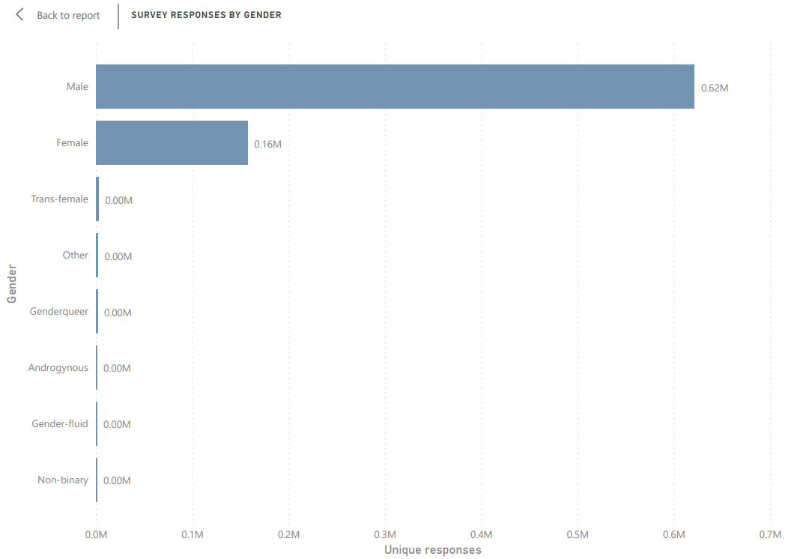

In my experience, females are usually the ones open to talking about mental health as well as answer surveys so finding males having a huge response rate was surprising. However, then I start to think of the lack of females in the tech industry and this does start to make sense. There are more females joining the tech industry work environment now but reading several articles along with working at a tech company myself most employees are male.

The second dashboard is named Benefits and included my visuals regarding employee knowledge of mental health benefits and programs available. Here it looked like there were quite a few employees who knew about existing benefits regarding mental health, but they were not confident in remaining anonymous if seeking help or whether leave was available. Employees also responded saying that no there are not care options or wellness programs that are currently available at their place of employment.

*Figure 2 – Survey Responses by Benefit Knowledge*

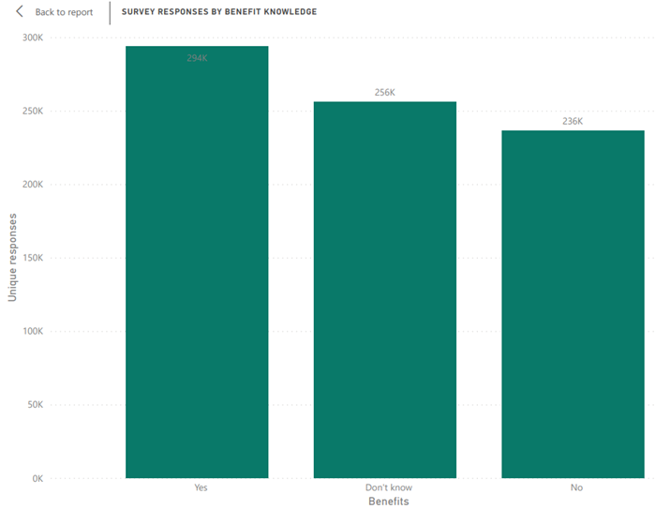

For my client, this would be somewhere I would make suggestions that not only do we need to make sure all benefits are easily accessible as well as published and marketed, but we need to offer wellness programs as well as multiple care options. This gives employees a variety of options to choose for their mental health.

The third dashboard I named In Workplace. This dashboard consisted of survey responses for consequences if employee talked about mental or physical health, whether respondent would bring up mental health in an interview, and lastly does the employer take mental health as seriously as it does physical health. The one I noticed the most in a good way was survey responses for observing other coworkers having consequences for sharing their mental health concerns. There were 0.66 million in the no category to the 0.13 million in the yes category. This is also something my client needs to think about is making sure that no one has negative consequences for sharing their mental health concerns, as that can easily break an employee’s trust. I also found it interesting that more respondents felt comfortable sharing their mental health concerns with their supervisor while the highest response for sharing with coworkers was ‘some of them.’ It makes sense since your relationship with your direct supervisor should consist of confidentiality as well as have a certain level of trust.

*Figure 3 – Survey Responses for Sharing Mental Health with Coworkers and Survey Responses for Sharing Mental Health with Supervisor*

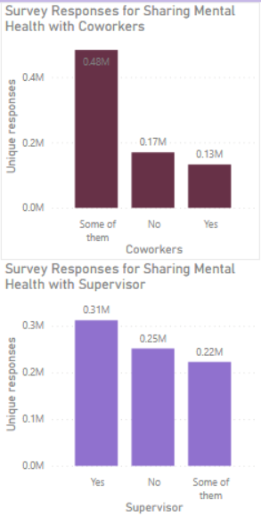

The biggest takeaway from this dashboard with the visualizations is that my client will need to foster a welcoming environment where discussing mental health issues can be done so without fear of retaliation.

Technical Analysis

For my technical analysis I have just started. I have created a new Jupyter notebook and read in the cleaned csv. The first thing I wanted to look at was if there was a relationship between a respondent having a family history of mental issues and whether those same respondents had also sought treatment. I wanted to see if there was a potential hereditary issue that needed to be investigated. For this I made sure the responses were yes’s and no’s then updated them to 1’s and 0’s. I then looked at correlation between family_history and treatment. After consulting with my resource, my correlation has a moderate, positive relationship between the two variables. (Ratner, 2009) It is interesting that there is a heredity between family history of mental health issues and employees having to seek treatment. This is a tricky area because we cannot just ask employees if they have a history, so it may just require some marketing that is not obvious that these employees are the target audience.

The second correlation I wanted to look at was between working from home and seeking treatment. Now this is 2014, so working remote was not as popular as it is now especially since Covid-19 was the real reason so many of us are remote now. However, I wanted to look at this because I have heard mixed reviews on remote working being good or not on mental health. As I expected there were more 0’s than 1’s for remote work so I did not have a large population that worked remotely. My correlation came back as 0.03, which is a weak relationship. I then looked at value counts for remote work by treatment and came back with 195 responses for seeking help while working remote compared to the 1,056 other responses.

After looking at some correlation I decided to switch gears and work towards answering whether Age_Groups or Gender had any impact on willingness to talk about mental health with either coworkers or supervisor. For this I just wanted to compare numbers, so I grouped by Gender and then added willingness to talk to coworker from there. The most common response I found here for most genders was that they would talk to some coworkers about mental health but not all. I then took the grouped by for Gender and looked at willingness to share mental health issues with supervisors. Most of the gender categories I have said either no or some of them, except for Males. Males had 433 out of 990 responses say they would share with a supervisor. Again, I found this surprising because I would not expect a male to be more willing to talk to someone of authority about their mental health. However, females answered exactly how I expected being more hesitant in sharing. I think this is because of the overall inequality in wages and respect that females already experience in the workplace why add more? Next, I looked at the Age Groups by willingness to share mental health with coworkers. All of the age groups were consistent in saying they would share with some with no being the next most common answer. For sharing with a supervisor, I was surprised at seeing that the most common answer was yes. I expected here for some of the older age groups to be less forthcoming since mental health was not widely talked about until more recently. Some of the employees in the younger age groups have experienced a consistent exposure to making sure to prioritize mental health versus the older age groups, so this was a good surprise.

My next question to answer was if an employer takes mental health as seriously as physical health, and whether that influences an employee’s knowledge of benefits. First was looking at mental_vs_physical compared to knowledge of benefits. Here the answers I saw in mental_vs_physical was mirrored in benefit knowledge. For example, if a respondent said no their employer does not take mental health as seriously the response for knowledge of benefits was also no. Next it was the comparison for care_options. Here the answers differed some with those who did not know if an employer took mental health as seriously also did not have knowledge of care_options. The others both had higher ‘Yes’ responses. For wellness_program the highest response in comparison to mental_vs_physical was no. I kind of expect his as wellness programs seem to be a more recent development. I think my company just added this as part of our benefits in 2019 or 2020. My last comparison was with mental_vs_physical and seek_help. The highest answer here was no. Again, this could be because it is a more recent addition to many companies benefit program.

The last analysis I wanted to do, was to look at benefit knowledge and consequences by country to see if that had any affect. I tried a few things within Python here but found creating tables in PowerBi was much easier. I added two additional dashboards called Benefits by Country and Workplace Environment by Country. For benefit knowledge across countries the most common answer was either no or don’t know. However, the United States had a much higher response rate of yes in comparison to other countries. It is worth knowing that in response rate totals the US had a higher response than other countries so this could be causing the higher trend of yes. For consequences in the workplace, most countries had high responses of no negative consequences for either mental health or physical health. In sharing with coworkers or supervisor the highest response was ‘some of them.’ With sharing mental or physical health during an interview, most countries said no with maybe being the next most common answer. For mental_vs_physical the response rate was more varied. For example, Germany had 5,191 no responses to 11,1119 yes responses. Lastly, on the observation of negative consequences affecting a coworker who shared their mental health the most common response was no, except for New Zealand and the Philippines which had a higher rate of yes.

The biggest takeaway from looking at country specific responses is that most countries need to spend more time marketing available benefits. This would help change the large response rate of ‘don’t know.’ The next thing is to add more to existing programs that might allow employees to work at achieving or maintaining a health mentality.

**Conclusion**

This investigation has been quite different than others I have completed in the past. The biggest reason is I did not need to follow a more traditional modeling approach and use algorithms to help answer my questions. Here correlation and doing a comparison of value counts provided answers to all my questions. I also used visualizations to look at trends in the data. Overall, it looks like my client could do some things differently than those that were a part of this survey. As mentioned previously marketing of available benefits needs to increase as there were entirely too many responses of employees not knowing what was available to them. I would also push my client to add wellness programs along with more resources on how/where to seek help as this seemed to be an area that was not well thought out at least in 2014. The last thing I would advise is to make sure my client spends as much if not more time on addressing mental health in comparison to physical health. The tech industry usually has tight deadlines, fire drills, bugs, etc. that can lead to stress and anxiety, so it is important that mental health is taken care of. This will help keep employees mentally healthy as well as ensuring they know that they matter to my client and are not just seen as cogs in the wheel.

**10 Questions**

1. Does it matter location when it comes to knowledge of benefits?
2. Why have 8 different types of genders?
3. Do you plan to investigate the different answers with negative consequences between mental and physical health?
4. Will your client keep everything completely anonymous or confidential?
5. What types of wellness programs do you think your client will incorporate into their existing benefits?
6. How does respondent confidence change by size of employer?
7. Will you look at the different states as well as countries for more specifics?
8. How will your client handle the uncertain answers when it comes to sharing mental health concerns in the workplace?
9. If a respondent had observed negative consequences to someone else sharing their mental health how would your client react?
10. Why does your client want to know about other tech companies’ mental health benefits?

# References

Davis, M. (2018, October 8). *The Conversation on Mental Health is Changing the Tech Industry and Supporting Employee Wellbeing*. Retrieved from Thriveworks: https://thriveworks.com/blog/mental-health-tech-industry-employee-wellbeing/

Lopukhina, D. (2020, February 20). *Are We TAckling Mental Health in Tech Companies the Right Way?* Retrieved from Thriveglobal: https://thriveglobal.com/stories/are-we-tackling-mental-health-in-tech-companies-the-right-way/

Open Sourcing Mental Illness, L. (2016, November 3). *Mental Health in Tech Survey*. Retrieved from kaggle: https://www.kaggle.com/osmi/mental-health-in-tech-survey

Ratner, B. (2009, May 18). *The Correlation Coefficient: Its values range between +1/-1, or do they?* Retrieved from Springer Link: https://link.springer.com/article/10.1057/jt.2009.5

# Appendix

*Table 1 – Variables from Dataset* (Open Sourcing Mental Illness, 2016)

|  |  |
| --- | --- |
| **Variable** | **Description** |
| Timestamp | Time survey was submitted |
| Age | Age of respondent |
| Gender | Gender of respondent |
| Country | Country respondent resides |
| State | State of respondent, if applicable |
| Self_employed | Is the respondent self employed? |
| Family_history | Does the respondent have family history of mental illness? |
| Treatment | Has respondent sought treatment for mental health condition |
| Work_interfere | If respondent has a mental condition, does it interfere with work? |
| No_employees | Number of employees at respondents company |
| Remote_work | Does company respondent works at allow at least 50% work from home? |
| Tech_company | Is employer primarily a tech company? |
| Benefits | Does employer provide mental health benefits? |
| Care_options | Does the respondent know what care options are available for mental health? |
| Wellness_program | Has employer discussed mental health as part of the employee wellness program? |
| Seek_help | Does employer provide resources to learn more and seek help? |
| Anonymity | Is anonymity protected if respondent chooses to use mental health or substance abuse treatment? |
| Leave | Is it easy to take leave for a mental health condition? |
| Mental_health_consequence | Do you think talking about a mental health issue with your employer would have negative consequences? |
| Phys_health_consequence | Do you think talking about a physical health issue with your employer would have negative consequences? |
| Coworkers | Would respondent be willing to discuss a mental health issue with a coworker? |
| Supervisor | Would respondent be willing to discuss a mental health issue with supervisor? |
| Mental_health_interview | Would respondent share about a mental health condition to a potential employer in an interview? |
| Phys_health_interview | Would respondent share about a physical health condition to a potential employer in an interview? |
| Mental_vs_physical | Does respondent feel that employer takes mental health as seriously as physical health? |
| Obs_consequence | Has respondent ever seen any negative consequences happen to a coworker who talked about their own mental health condition at work? |
| Comments | Any comments respondent felt needed |

*Figure 1 – Overview Dashboard*

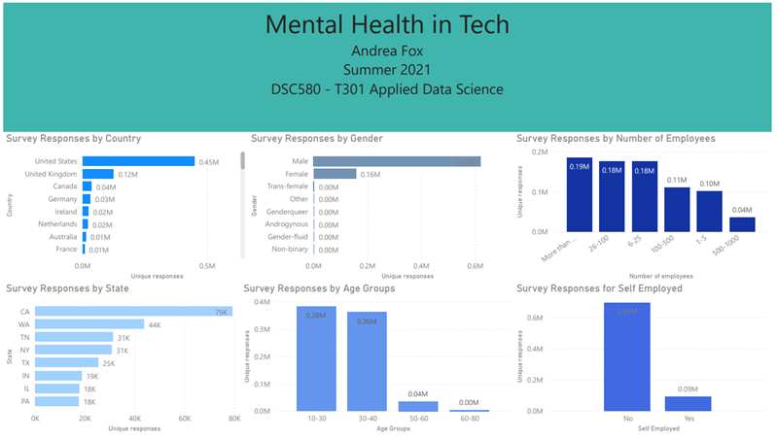

*Figure 2 – Benefits Dashboard*

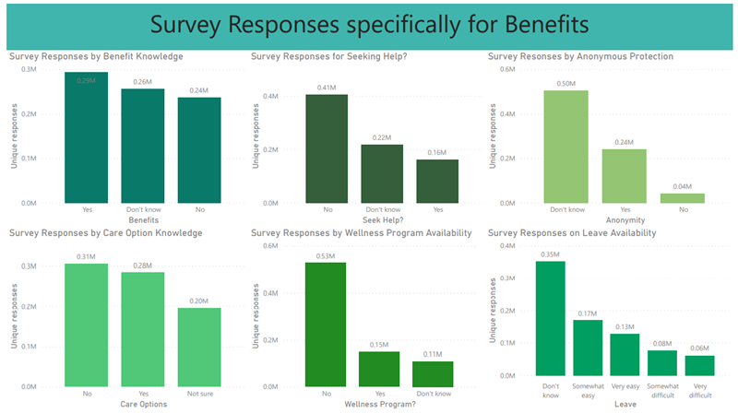

*Figure 3 – In Workplace Dashboard*

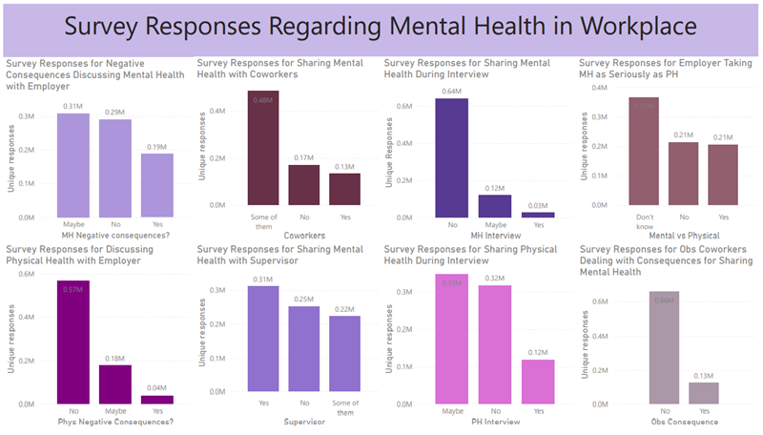

*Figure 4 – Awareness of Benefits by Country*

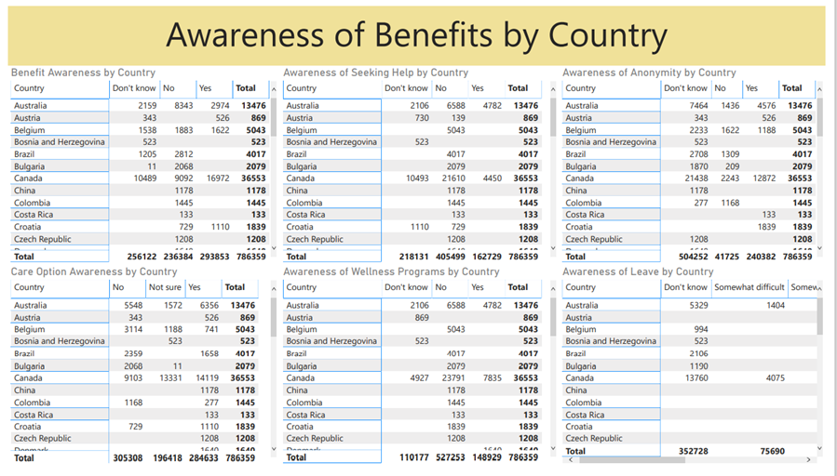

*Figure 5 – In Workplace Environment by Country*

